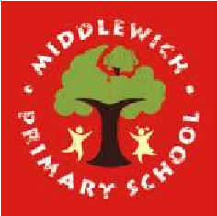
Middlewich Primary School
Personal Development Awards

Challenges to be completed at home | Completed | Challenges to be completed at school | Completed
Make a fruit kebab |  | Make yourself a snack plate for a teddy bear’s picnic
Post a card to someone you love |  | Meet somebody who works to help our community
Tidy your bedroom, making sure all your books, toys and clothes are away |  | Make sure your coat and bag are neatly on your peg
Tell a grown-up if somebody is hurt |  | Participate in a performance for others
Comfort somebody who is hurt or sad |  | Learn and recite a nursery rhyme
Take part in a water fight |  | Play a throwing game using hoops as goals

Appendix 1b
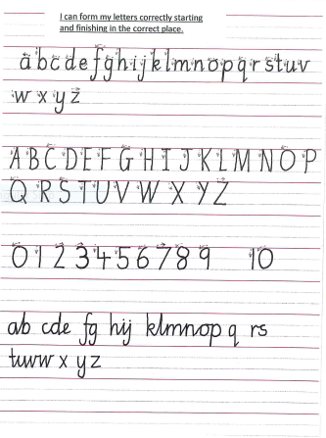
Appendix 2

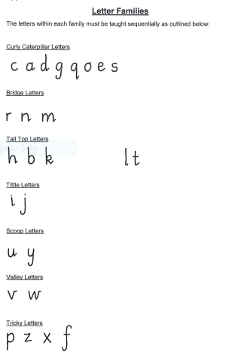

Appendix 3

Commentary to accompany correct letter formation

Curly caterpillar letters:
c over the top, round
a over the top, round, up, down, flick
d over the top, round, up, tall top, down, flick
g over the top, round, up, down, monkey’s tail
q over the top, round, up, right down, flick

o over the top and all the way round, flick
s curly “c”, round the other way
e loop, over the top, round

Bridge letters
r down, up, almost over, flick
n down, up, all the way over, flick
m down, up, all the way over, and again, flick

Tall top letters
h start at the top, down, up, over, flick
b start at the top, down, up, all the way round
k start at the top, down, up, loop, kick and flick

l start at the top, down, flick
t almost at the top, down, hook, and cross

Tittle letters
i down, flick, and a little dot
j down, monkey’s tail and a little dot

Scoop Letters
u down, scoop, down, flick
y down, scoop, monkey tail

Valley Letters
v down the slope, up the other side, flick
w down the slope, up the other side, and again, flick

Tricky Letters
p right down, up, all the way round,
z straight, zig, zag
x across and across
f over the tall top, down the monkey’s tail, and cross

Appendix 4
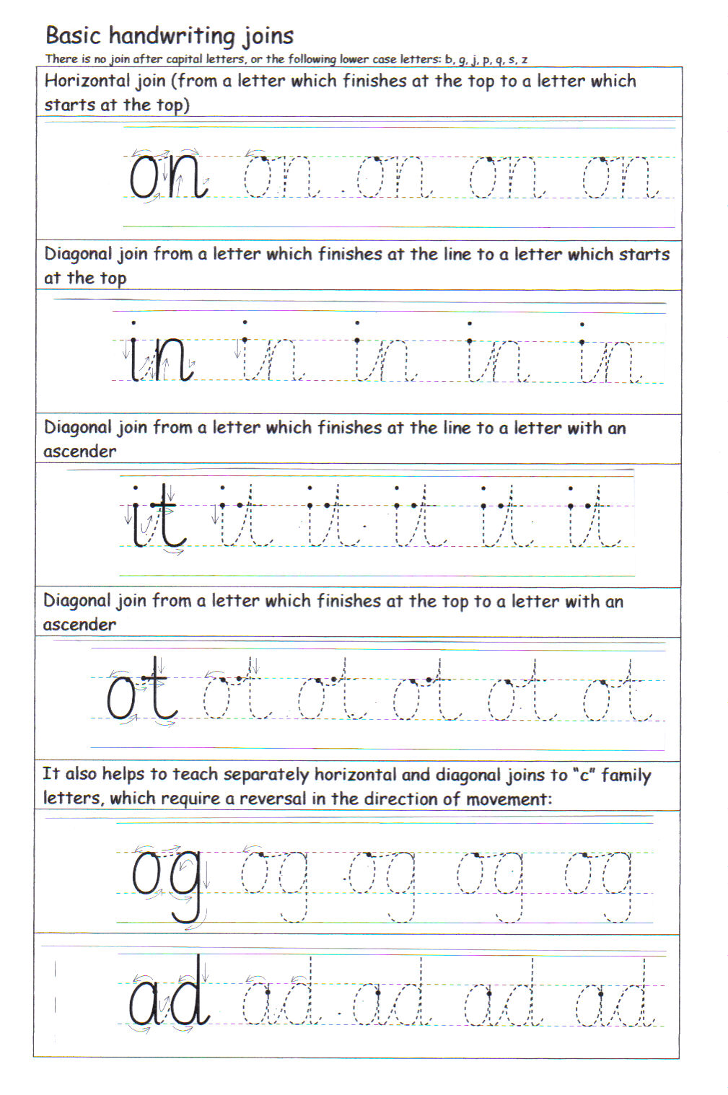
Appendix 5

Appendix 6

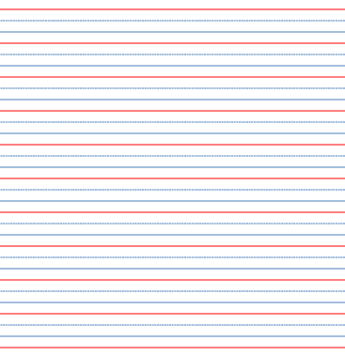

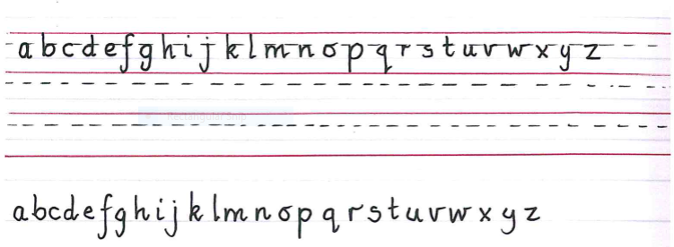
Example:

Appendix 7
Middlewich Primary School
Good Handwriting Guide

At Middlewich Primary School we want our handwriting to be easy to write, fluent and legible.
We aim to write so that:
- Our writing is well presented and makes us feel proud
- All letters are formed correctly
- All the letters are the same regular size
- All letters are on the line
- Words are evenly spaced apart
- Capital letters are never joined
- Letters in words are close together
- All ascenders are tall, but not to the top of the line above
- Descenders are below the line but don’t reach the words below
- Writing goes to the end of each line but words are not squashed or separated
- The letters C O S U V W are the right size depending on whether they are lower or upper case
- Writing is not too big and not too small
- Each line starts at the margin (unless it is a new paragraph)
- Writing is joined in key stage 2

Please ensure that you:
- Cross out mistakes with a single line using a pencil and ruler. No scribbles and no rubbers!
- Underline titles, dates and headings with a ruler and a pencil
- In years 1- 4, the date goes on the left hand side at the top of the page. In years 5 & 6, the date goes on the right hand side. The date should not fill the height of the top line.
- Sit in the correct position if you are left-handed
- Use your free hand to hold the paper, not your head. Don’t lean on your elbow!
- Try your best to use a tripod grip
- Hold your pen above the nib

Appendix 8
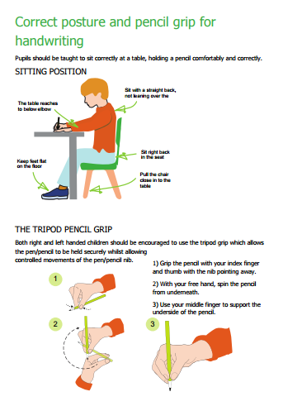

Appendix 9

Improving Handwriting

Name____________________________

Am I doing all of these things correctly?
 | tick |  | tick
Write on the line |  | Speech marks not too big
Hold pen correctly |  | Join letters correctly
Underline headings and dates |  | Not slanting in different directions
Spacing of words- make consistent |  | Capital letters correctly sized
Use of margin to place writing |  | Cross out using a single neat line
Correct formation of each letter |  | Use of correct pen or a sharp pencil
Regular sizing of each letter |  | Ascenders letters, tall enough
Words not cramped at the end of the line |  | Dot i and j
Lower case ‘s’ the correct size |  | Descenders (f, g, j, p, q, y) are not too long
Small full stops |  | Lower case descenders letters under the line
Writing is not too small |  | Accurate copying
Writing is not too big |  | Cross the ‘t’s
Hyphens above the line |  | Writing enough in the time
Punctuation sitting on the line |  | Page positioned correctly on the desk
No space before commas |  | Correct posture

My handwriting targets

Date target set | Details of the action I will take | Date achieved | Teacher’s initials | Student’s initials

Appendix 10

The National Expectations for Handwriting

Year Group | National Curriculum Expectations  (EYFS- Early Learning Goals)
EYFS | Pupils should be taught to:  - Use some clearly identifiable letters to communicate meaning, representing some sounds correctly and in sequence  - Write own name and other things such as labels and captions  - Attempt to write short sentences in meaningful context  - Use a pencil and hold it effectively to form recognisable letters, most of which are formed correctly.
Year 1 | Pupils should be taught to:  - sit correctly at a table, holding a pencil comfortably and correctly  - begin to form lower-case letters in the correct direction, starting and finishing in the right place  - form capital letters  - form digits 0-9  - understand which letters belong to which handwriting ‘families’ (i.e. letters that are formed in similar ways) and to practise these.
Year 2 | Pupils should be taught to:  - form lower-case letters of the correct size relative to one another  - start using some of the diagonal and horizontal strokes needed to join letters and understand which letters, when adjacent to one another, are best left unjoined  - write capital letters and digits of the correct size, orientation and relationship to one another and to lower case letters  - use spacing between words that reflects the size of the letters.
Year 3 & 4 | Pupils should be taught to:  - use the diagonal and horizontal strokes that are needed to join letters and understand which letters, when adjacent to one another, are best left unjoined  - increase the legibility, consistency and quality of their handwriting [for example, by ensuring that the down-strokes of letters are parallel and equidistant; that lines of writing are spaced sufficiently so that the ascenders and descenders of letters do not touch].
Year 5 & 6 | Pupils should be taught to:  - write legibly, fluently and with increasing speed by: choosing which shape of a letter to use when given choices and deciding whether or not to join specific letters  - choosing the writing implement that is best suited for a task

End of Key Stage Expectations

End of Key Stage 1: Year 2
Working towards the expected standard | - forming lower-case letters in the correct direction, starting and finishing in the right place  - forming lower-case letters of the correct size relative to one another in some of the writing  - using spacing between words.
Working at the expected standard | - using the diagonal and horizontal strokes needed to join letters in some of their writing  - writing capital letters and digits of the correct size, orientation and relationship to one another and to lower case letters  - using spacing between words that reflects the size of the letters.
Working at greater depth within the expected standard | - using the diagonal and horizontal strokes needed to join letters in most of their writing

End of Key Stage 2: Year 6
Working towards the expected standard | - producing legible joined handwriting.
Working at the expected standard | - maintaining legibility, fluency and speed in handwriting through choosing whether or not to join specific letters.
Working at greater depth within the expected standard | No additional requirements for handwriting.

