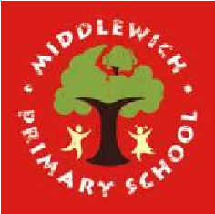
Middlewich Primary School
Personal Development Awards

Challenges to be completed at home | Completed | Challenges to be completed at school | Completed
Make a hot chocolate |  | Make a pizza
Help an adult to wash the car |  | Send an email to your teacher
Dust the windowsills in your house |  | Learn about fire safety
Explain how to treat a nosebleed |  | Learn how to treat a burn
Say or sing a line by yourself as part of a performance |  | Perform using a percussion instrument, carefully counting the beat
Build a den |  | Visit the swimming baths

