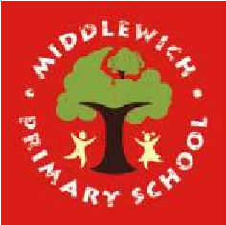
Middlewich Primary School
Personal Development Awards

Challenges to be completed at home | Completed | Challenges to be completed at school | Completed
Make a fruit smoothie |  | Learn about the job of somebody who works to help our community
Send a handwritten letter to a friend or relative |  | Learn to clean a cut and put on a plaster
Tidy your room and make your bed neatly |  | Learn and recite a poem
Help to do some dusting in your house |  | Make a sandwich
Learn your home address and how to give it to a 999 operator |  | Learn and sing a song to an audience
Go on a walk with your family |  | Play a throwing game using hoops as goals

