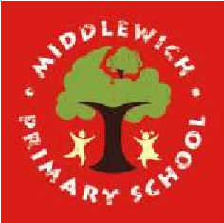
Middlewich Primary School
Personal Development Awards

Challenges to be completed at home | Completed | Challenges to be completed at school | Completed
Explain some of the signs of an allergic reaction |  | Plan and cook a balanced meal for others to enjoy
Cook a meal for your family |  | Write a letter to somebody at Willowmere
Wash a family member’s car for them |  | Learn basic CPR
Take the bins out ready for the refuse collectors and then bring them back in again |  | Learn to sign a song
Teach somebody younger how to play a physical game |  | Help to plan, and perform, the leavers’ assembly
Go litter-picking within the community |  | Play a game of cricket, showing an awareness of the rules

