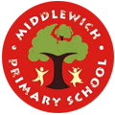
MIDDLEWICH PRIMARY SCHOOL
NEWSLETTER DECEMBER 2024

Christmas will soon be here and our school is beginning to look and sound very festive. We have a beautiful Christmas tree in the main entrance, decorated with creations made by our children in craft after-school club. Throughout December, we look forward to many festive events, including the PTFA Christmas Fair, the children’s Christmas performances and our class Christmas parties. Please see the key dates below to stay informed.

DATES FOR YOUR DIARY
Friday 6th December | PTFA Christmas Fair | 5 pm to 7:30pm
Tuesday 10th December | Year 1 Christmas Performance to Parents/Carers | 9:15am
Tuesday 10th December | Year 2 Christmas Performance to Parents/Carers | 2pm
Wednesday 11th December | Year 2 Christmas Performance to Parents/Carers | 9:15am
Wednesday 11th December | EYFS Nativity to Parents/Carers | 2pm
Thursday 12th December | EYFS Nativity to Parents/Carers | 9:15am
Thursday 12th December | Year 1 Christmas Performance to Parents/Carers | 2pm
Friday 13th December | Year 2 Singing at Willowmere | morning
Friday 13th December | Christmas Dinner Day | 12pm
Tuesday 17th December | EYFS visit to New Vic Theatre
Tuesday 17th December | Year 5 Christmas Party | 9am
Tuesday 17th December | KS2 Visit to St Michael’s Church | afternoon
Tuesday 17th December | Christmas Carols by Candlelight | 6pm
Wednesday 18th December | Year 3 Christmas Party | 10am
Wednesday 18th December | Year 4 Christmas Party | 1pm
Thursday 19th December | Year 6 Christmas Party | 9am
Thursday 19th December | Year 1 and Year 2 Christmas Parties | 1:30pm
Friday 20th December | EYFS Christmas Party | 11am
Friday 20th December | School Closes for Christmas | 3.15 pm & 3.20 pm
Monday 6th January | School Opens | 8:40am
Wednesday 22nd January | PTFA meeting at school | 6pm
Thursday 30th January | Y6 Whitby 1 night residential

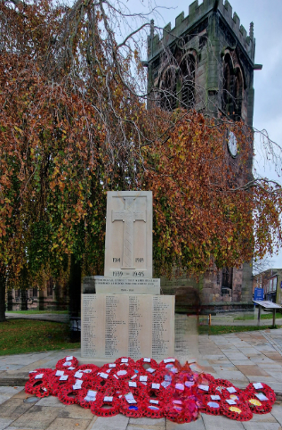
Remembrance Day
On Monday 11th November our year 5 children visited Middlewich’s war memorial to hold a memorial service and pay their respects. A special thank you to our year 6 sports and events team for their efforts in selling poppies and other merchandise, raising an impressive £319.62 for The Royal British Legion. Thank you to all families who supported this wonderful cause. Our head pupils also represented the school with pride during the remembrance parade on Sunday 10th November where they laid a wreath on behalf of Middlewich Primary School. A huge thank you to them for their contribution to this important event.

School Visits
Our children have had the opportunity to enjoy a variety of enriching school visits this term. Since our last newsletter, year 3 thoroughly enjoyed watching The Three Musketeers at the New Vic Theatre. Year 5 have been on a local walk to explore the local architecture in Middlewich to inspire their Lowry artwork.

EYFS Diwali Workshop
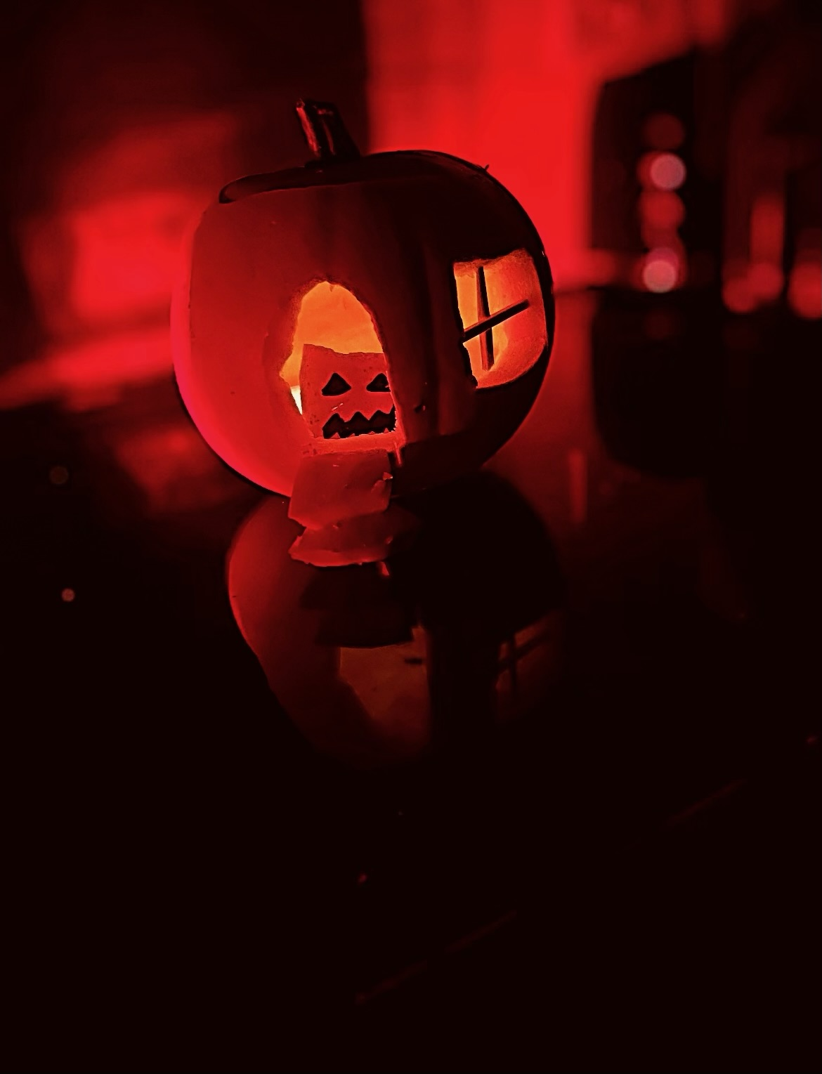
Our reception children had an exciting time participating in a Diwali workshop. They listened to the story of Rama and Sita, learning about the traditions and significance of the festival. The children enthusiastically joined in with traditional dances, bringing the story to life. This workshop was thoroughly enjoyed by all.

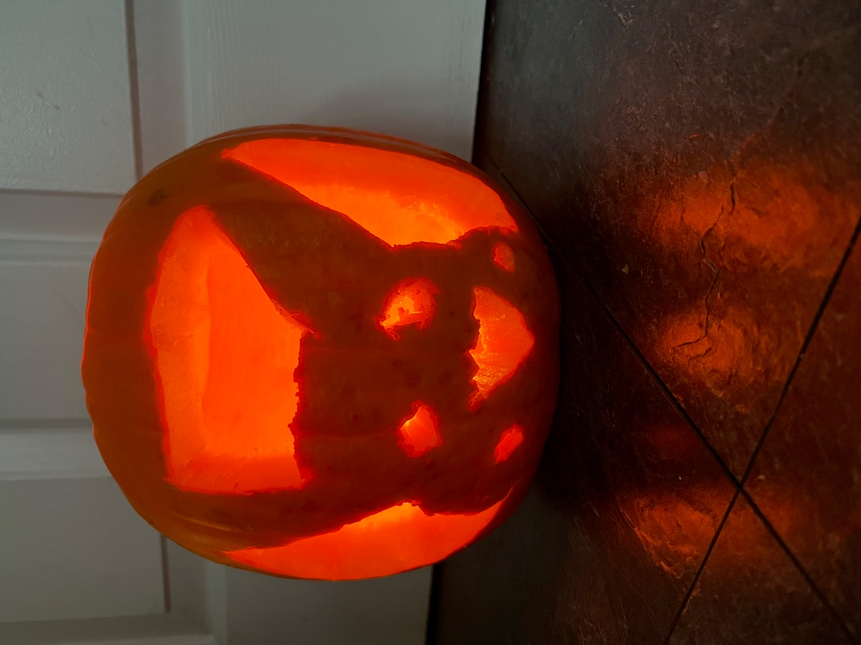
Pumpkin Decoration Competition
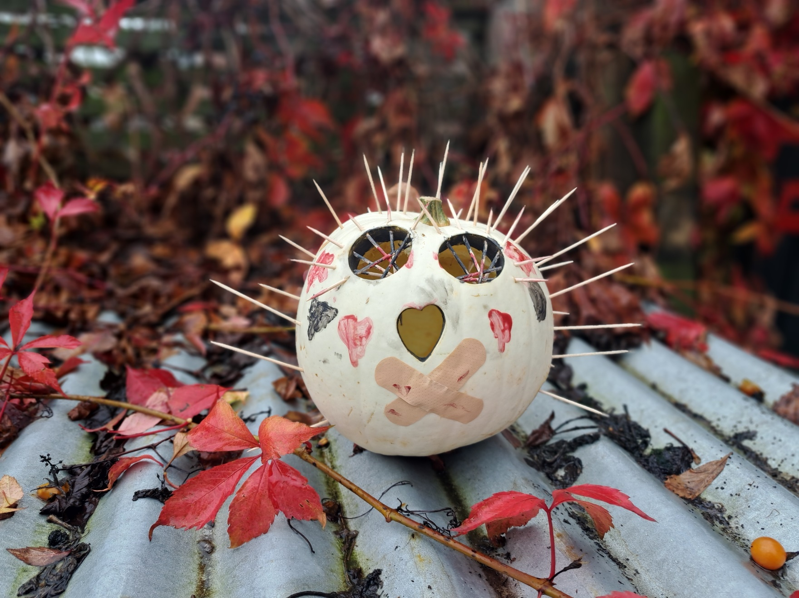
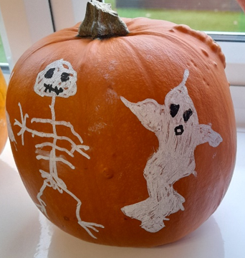

Our year 6 sports and events team did s fantastic job leading a spectacular pumpkin decoration competition. A huge well done to all the children who took part – you showcased incredible creativity and talent! All classes enjoyed seeing all the fabulous photographs of the different pumpkins. Brilliant work, everyone!
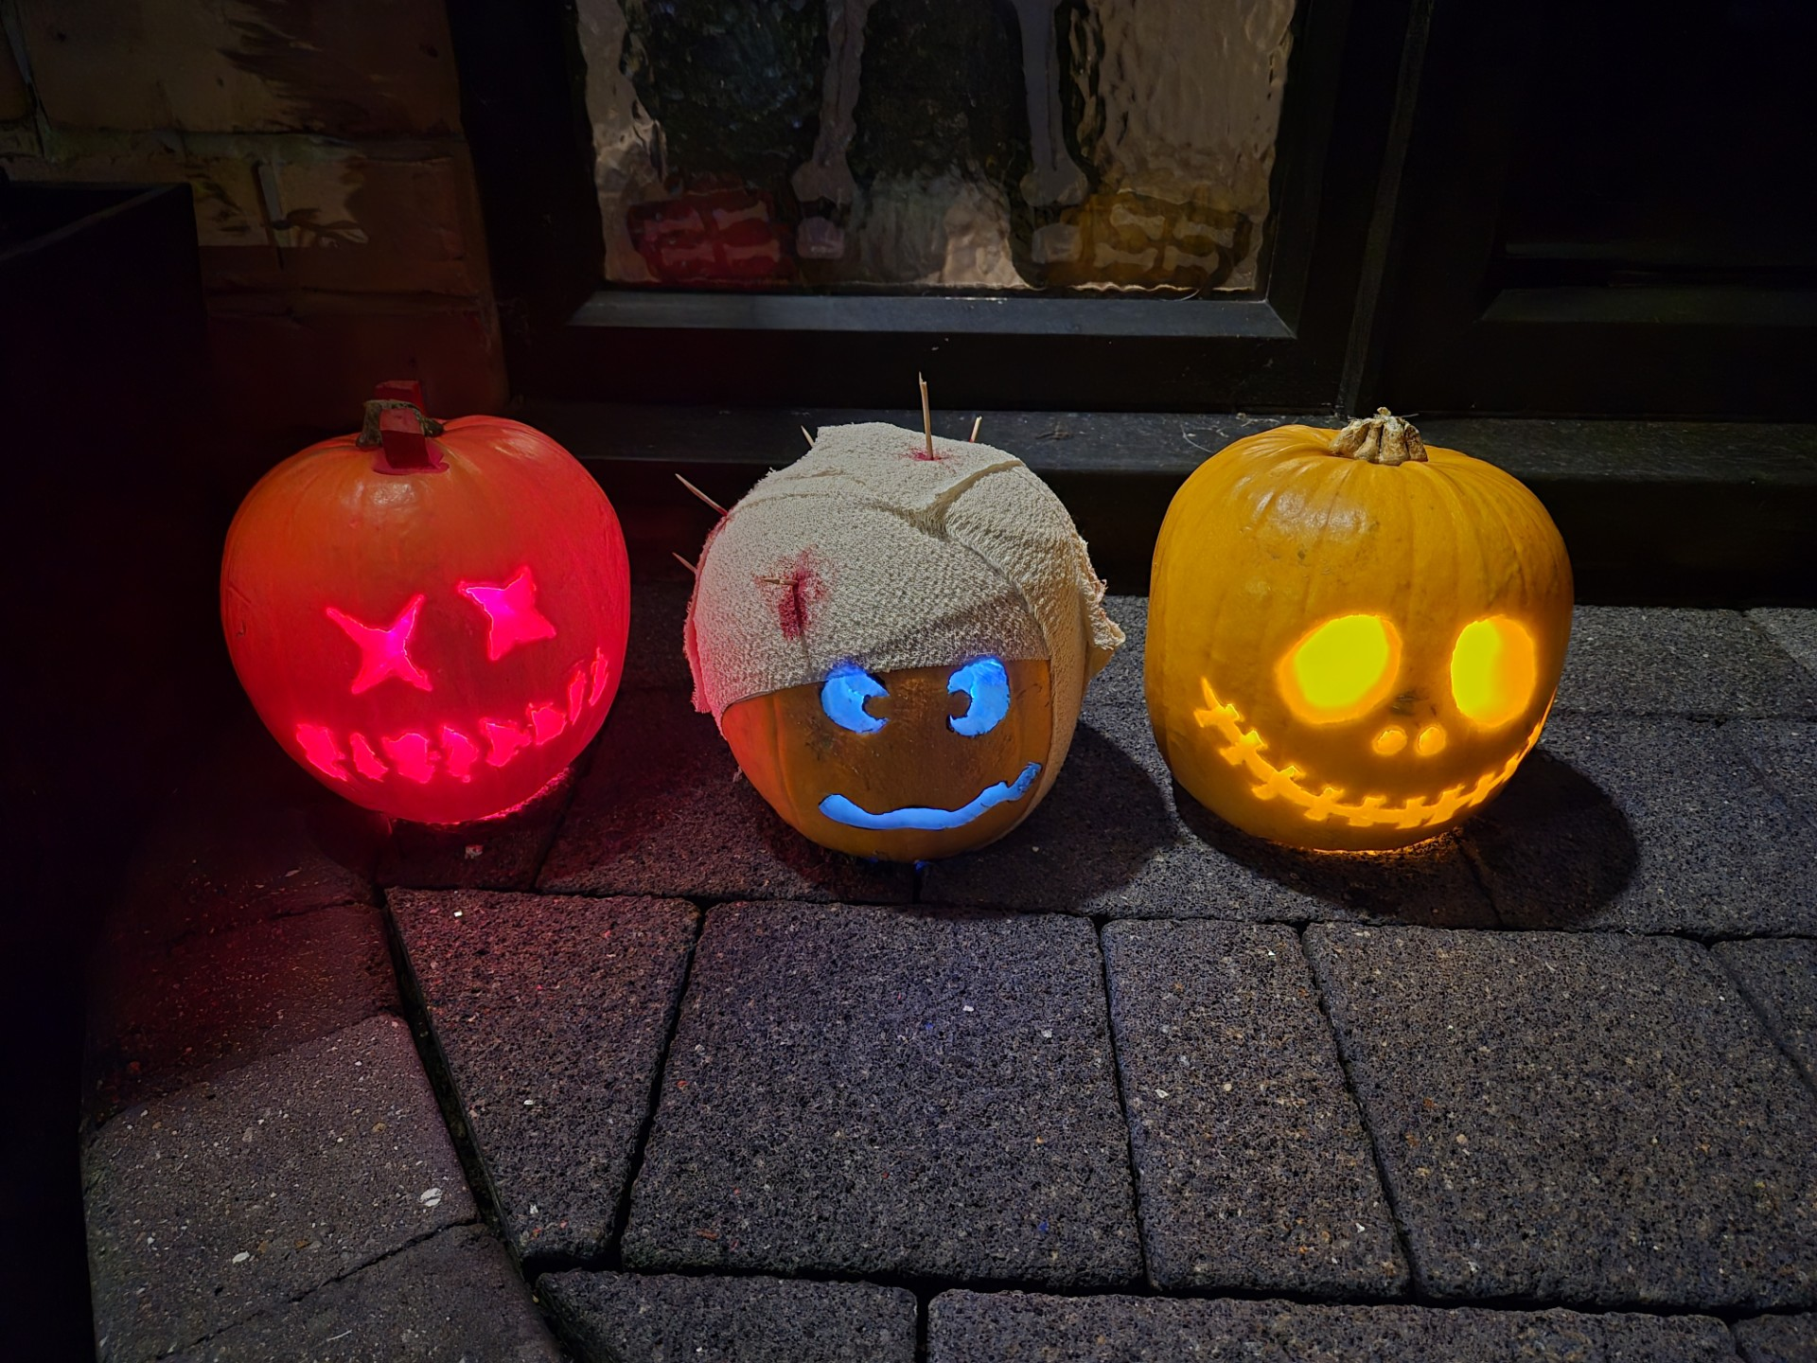

Children in Need
The children had lots of fun on Friday 15th November as they came dressed in their pyjamas, spotty clothes, fancy dress or onesies for Children in Need. Thanks to the incredible generosity of our parents and carers, we are delighted to announce that we raised over £350! Well done Middlewich Primary School. A special mention goes to some of our year 5 pupils who went the extra mile by creating and selling items at school, donating all proceeds to Children in Need. Well done, Middlewich Primary School, for coming together to make a difference.


Staff News
Exciting News from year 6 - Miss Harding got married during the half term break! We would like to say a huge congratulations to her as she begins this new chapter. She will now be known at Mrs Collinge. Best wishes to the happy couple!

School Uniform
We kindly remind parents and carers that leggings are not part of our school uniform and should not be worn to school. For full details of our school uniform requirements, please visit our school website: https://www.middlewichprimary.org/page/school-uniform/6758


PTFA News
A huge thank you to all our families who supported the PTFA Fireworks this month. It was a lovely evening and lots of fun was had by everyone. We are now looking forward to our Christmas Fair which will be held on Friday 6th December from 5pm to 7:30pm. Thank you to the parents/carers who have volunteered their time to help make this festive event a success. The next PTFA meeting will take place on Wednesday 22nd January at 6pm at school. Please do come along if you can spare some time to support our dedicated PTFA team.

Sunrise and Sunset Squad

We are pleased to offer both breakfast and after-school provision. To secure your child’s place, please visit our online booking portal: https://middlewich-primary.hivelink.co.uk/ For further details, visit our school website via the following link: https://www.middlewichprimary.org/page/breakfast-after-school-club/136853 As the children often play outdoors during Sunset Squad, if you arrive and no one is present, please contact our Sunset Squad staff on 07396 819195.

Gritting Plan Information
During cold weather, please adhere to the gritting plan posted on the school gates. This is asking everyone using the school grounds to stick to the gritted paths for your safety.

Start and End of the School Day
To ensure the safety of all, we kindly request that children refrain from using the play equipment at the beginning and end of the school day. Your cooperation in creating a safe environment for everyone is greatly appreciated. Middlewich Primary School cannot be held liable for any accidents that occur during these times. Thank you for your understanding.

E-safety
We currently do allow pupils in years 5 and 6 to bring a mobile phone to school if their parents/carers require them to do so for walking home reasons. However, children are explicitly informed that phones must not be used on school grounds and should be handed to the class teacher during registration. Children younger than year 5 or 6 should not bring phones into school.

Holidays in Term Time

We would like to remind all parents/carers that holidays should not be taken during school time. Holidays are only authorised in extremely exceptional circumstances. Unauthorised absences will be reported to the local authority, and a fixed penalty notice may be issued.

School Parking
Although we realise there are charges for parking in town, please can we remind you that unauthorised vehicles are not permitted on the school car park without prior authorisation from the headteacher. We ask everyone to park considerately and respectfully for our neighbours. Thank you for your cooperation in keeping our school community safe and respectful.

Thank you for your continued support.
Mrs Reynolds and all the staff at MPS

