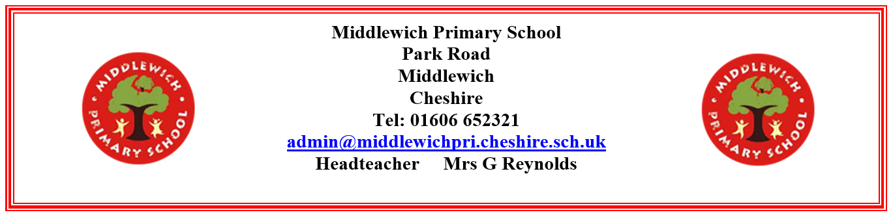

Friday 14th June 2024

Dear Parent/Carer,

**Year 2 visit to Macclesfield Forest on Friday 5th July 2024**

This term we will be taking the children to visit Macclesfield Forest on Friday 5th July. This will be a fantastic opportunity for our pupils as it links to our geography work where we have explored geographical features this term.

Children should arrive at school promptly at their usual time and we aim to return for home time at 3:15pm. The children will be required to wear their school uniform, with sensible bottoms (eg. leggings/jogging bottoms/trousers) and appropriate footwear for the forest environment. They should also bring a waterproof coat in case it rains.

The cost of the school trip will be £8.00 per pupil. You can pay for this trip online by following this link:

* + - * [**http://www.**](http://www.)**schoolgateway.com**

We will be having lunch at Macclesfield Forest. This can be provided by the kitchen in line with universal free school meals. If you will be providing your child with their own packed lunch, please put this in a disposable bag labelled with your child’s name. There will be nowhere to store lunchboxes or water bottles whilst we are there.

Please complete the link below by 27th June:

* <https://forms.office.com/e/w7MxPYaLL5>

Yours sincerely,

Miss Tosh and Miss Griffith

Year 2 teachers