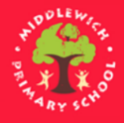
Year 2

Dear Year 2,

I am sure you have all been trying really hard to complete all the work I have planned for you so far to do at home. Well done for all of your efforts. It’s also been great to hear how you’ve been getting on in our blogs– I hope that you have been enjoying your home learning tasks! I have been very impressed with your efforts in our battles on Times Table Rockstars- well done!

Now it’s half term, I think you can have a well-deserved break! However, if you do want some ideas to keep you busy, there are plenty of fantastic ideas and links in the ‘Home Learning’ section on the website LINK and I have listed a few below too. It is also really important to stay fit and healthy so make sure that you are keeping active and we also always say try and practise your reading as much as you can.

I wish all of 2E a restful break. Look out for the new home learning sheet and blog on the 1st June.

Take care, Mr Edwards

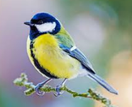
Task suggestions
- Create a wildlife survey. You could look for animals and birds while you are on a walk, in your garden or look out of your window. Use this LINK to identify any birds you may not recognise.

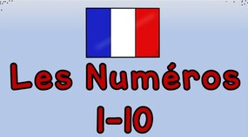
(2)Follow this LINK to learn how to count to 10 in French. Could you teach somebody else in your family? Play games to test your knowledge by following this LINK.
- Blue Peter badge challenge: Could you earn a blue peter badge over half-term? Follow the LINK to see which one you’d like to earn and what you’ve got to do!
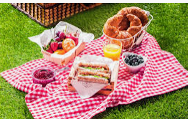
(4)Plan a picnic to take out on a walk. Can you help to create some of the things that your will take?

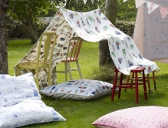
5) Make a den either in your house or perhaps outside in your garden. You could use your den to enjoy reading a favourite book or it could be a home for your teddies. .

