Year 3

Dear 3H,

Well done for all your hard work this half term. I hope you have been enjoying completing the home learning tasks. It’s been lovely to hear how you’ve been getting on in our blogs and emails.

Now it’s time for a well-deserved half-term break! However, if you do want some ideas to keep you busy, there are plenty of fantastic ideas and links in the ‘Home Learning’ section on the website LINK and I have listed a few below too. It is also really important to stay active in order to keep yourself fit and healthy. Make sure you are getting some fresh air each day. Keep up with your daily reading and times table practise. I have been really impressed with your efforts.

I wish all of you a restful break. Remember to look out for the new home learning sheet and blog on June 1st.

I look forward to hearing from you after half term,
Miss Harding

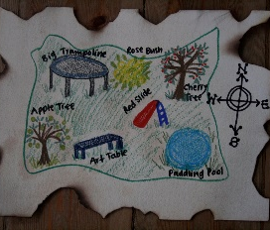
Task suggestions
- Design a treasure hunt in your house or garden. You could draw a map and leave a trail of clues.

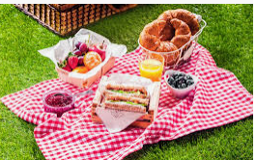
- Plan a picnic to take out on a walk. Can you help to create some of the things that you will take?

- Write a song to perform. You could use the tune of a song you know and change the words. You could make up a dance routine to go with it or use some household objects as instruments.

- See if you can identify some different trees in your garden or on a walk. Use this link to help you. I wonder how many you will find.

