Year 5

Dear 5B,

I hope you have all been enjoying and of course, working hard to complete all the work planned for you so far to do at home. Well done for all of your efforts and achievements! I am so impressed by the quality of the work and the enthusiasm you have shown towards each task. I am one very proud teacher!

I have thoroughly enjoyed hearing how you have been getting on in our blogs/email and the images you have uploaded onto our school Twitter account. A real highlight of mine is seeing you all on our Zoom sessions – I hope you are enjoying them as much as me!

Now it’s half term, I think you can have a well-deserved break and hopefully enjoy a bit of sunshine if the weather is nice! However, if you do want some ideas to keep you busy, there are plenty of fantastic ideas and links in the ‘Home Learning’ section on the website [Link] and I have listed a few below too. It is also important to stay fit and healthy so make sure that you are keeping active and we also always say try and practise your reading as much as you can.

I wish all of 5B a restful break. We will resume our Zoom sessions on the week beginning 8th June so please join me in your given time slot. Also look out for the new home learning sheet and blog.

Take care, Mrs Berry
Task suggestions
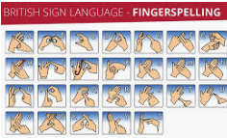
1.Follow this LINK to learn how to fingerspell in British Sign Language. Can you learn how to sign your name?
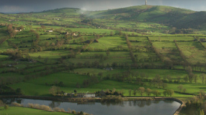
2.Tegg’s Nose Country Park is located close to Macclesfield in Cheshire on the western edge of the Peak District National Park. Discover a virtual ecological trail [Link] and take an ‘armchair walk’ around Tegg’s Park [Link].
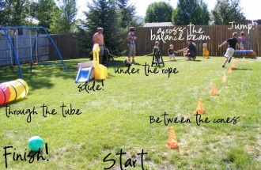

3.#CaptureTheMoon Photography Challenge [Link] Jodrell Bank Captures the Moon landing.

4.Set up an obstacle course in your garden. Time yourself and other members of your family. How creative can you be?

