Year 4

Dear 4S,

I am sure you have all been trying really hard to complete all the work I have planned for you so far to do at home. Well done for all of your efforts. It’s also been great to hear how you’ve been getting on in our blogs/email and to see you all on our Zoom sessions – I hope you are enjoying these!

Now it’s half term, I think you can have a well-deserved break! However, if you do want some ideas to keep you busy, there are plenty of fantastic ideas and links in the ‘Home Learning’ section on the website LINK and I have listed a few below too. It is also really important to stay fit and healthy so make sure that you are keeping active and we also always say try and practise your reading as much as you can.

I wish all of 4S a restful break. We will resume our Zoom sessions on the week beginning 8th June so please join me in your given time slot. Also look out for the new home learning sheet and blog.

Take care, Mrs Spreadbury

Task suggestions
- Plan a picnic to take out on a walk. Can you help to create some of the things that your will take?

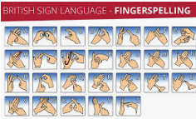
- Follow this LINK to learn how to fingerspell in British Sign Language. Can you learn how to sign your name?

- Board Game Challenge: Set a target of how many board games you will play with your family over the week

(4)Set up an obstacle course in your garden. Time yourself and other members of your family.
