FW | The Book With No Pictures  B.J Novak |  | ‘It always reminds me of my cousin because my cousin has it. My mummy reads it to me every night and says silly words that make me laugh.’
FPR | The Scare Crows Wedding  Julia Donaldson | 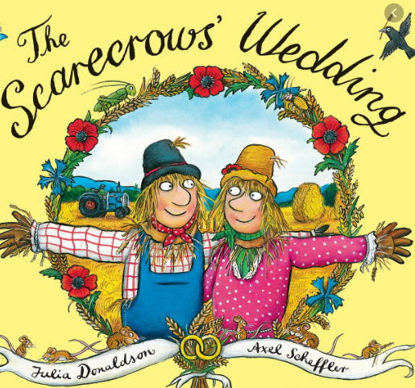 | ‘I like weddings and I find it very funny. My friends find it funny too!’
1S | Magic Faraway Tree  Enid Blyton | 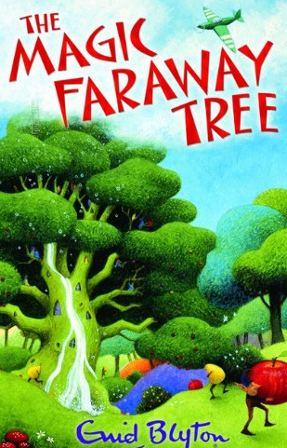 | ‘I like it because I read it with my mum.’
1P | The Paper Dolls  Julia Donaldson | 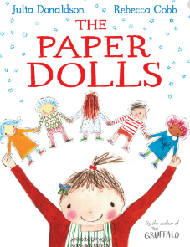 | ‘I like it when the characters lie on top of the farm house and look up at the stars.’
2W | Mog the Forgetful Cat  Judith Kerr | 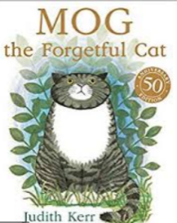 | ‘At the end she scares away the thief and gets a big gold medal as a reward. I like that the cat likes her garden as I like having fun in my garden at home.’
2E | The Cook and the King  Julia Donaldson | 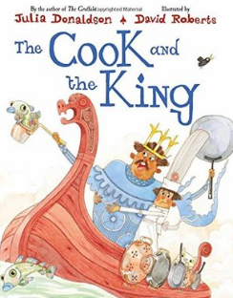 | ‘It is funny the king wants a cook and he cannot find the right one so he does it himself.’
3D | Jemima Puddle Duck  Beatrix Potter | 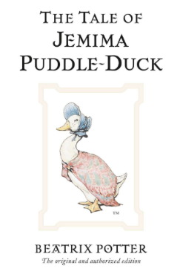 | ‘I like the characters in the story.’
3H | The Lorax  Dr Seuss | 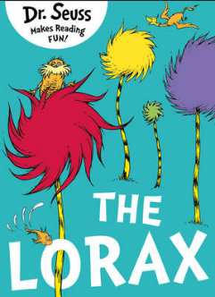 | ‘I like this story because it rhymes.’
4T | The Famous Five  Enid Blyton | 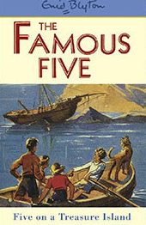 | ‘I like it because they go on lots of adventures they see a circus and talk to a clown who has a caravan and they want one to.’
4S | The Giraffe, the Pelly and Me  Roald Dahl | 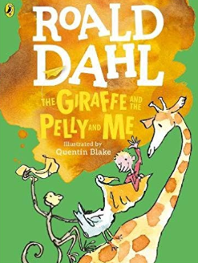 | ‘I like it because they sing a lot and the characters are very funny.’
4S | The Midnight Fox  Betsy Byers | 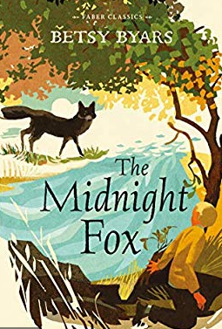 | ‘I like it because it inspires me about farm animals and I like animals.’
5B | First Term At Malory Towers  Enid Blyton | 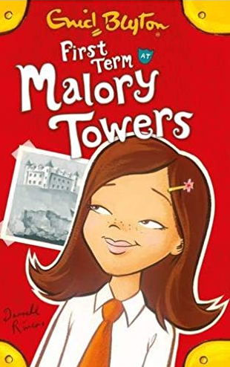 | ‘It is really special to me and I like all the characters. I like how the school looks like a castle.’
5W | The Enchanted Wood  Enid Blyton | 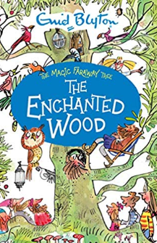 | ‘I like it because the go up the top of the tree and visit a variation of lands. There are also lots of different characters and they all have different characteristics .I like the character called Moon Face and Dane Wash-a-lot because moon face has a special slide in his house which h he uses to get to the bottom of the tree and Dane – Wash – A –Lot pours water over the children.’
6M | The Curious Incident of the Dog in the Night time  Mark Haddon | 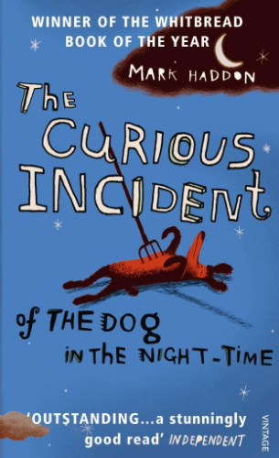 | ‘This book is very famous. Both of my parents have read it and I know a lot of people who have recommended it. Also it is very old but still enjoyable today!’
6M | Harry Potter and the Philosopher’s Stone  J.K Rowling | 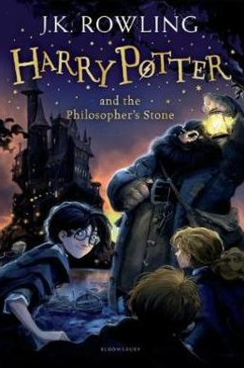 | ‘It is a really good book and lots of people that I know of like it all across the world. I think it is the best Harry Potter book.’

